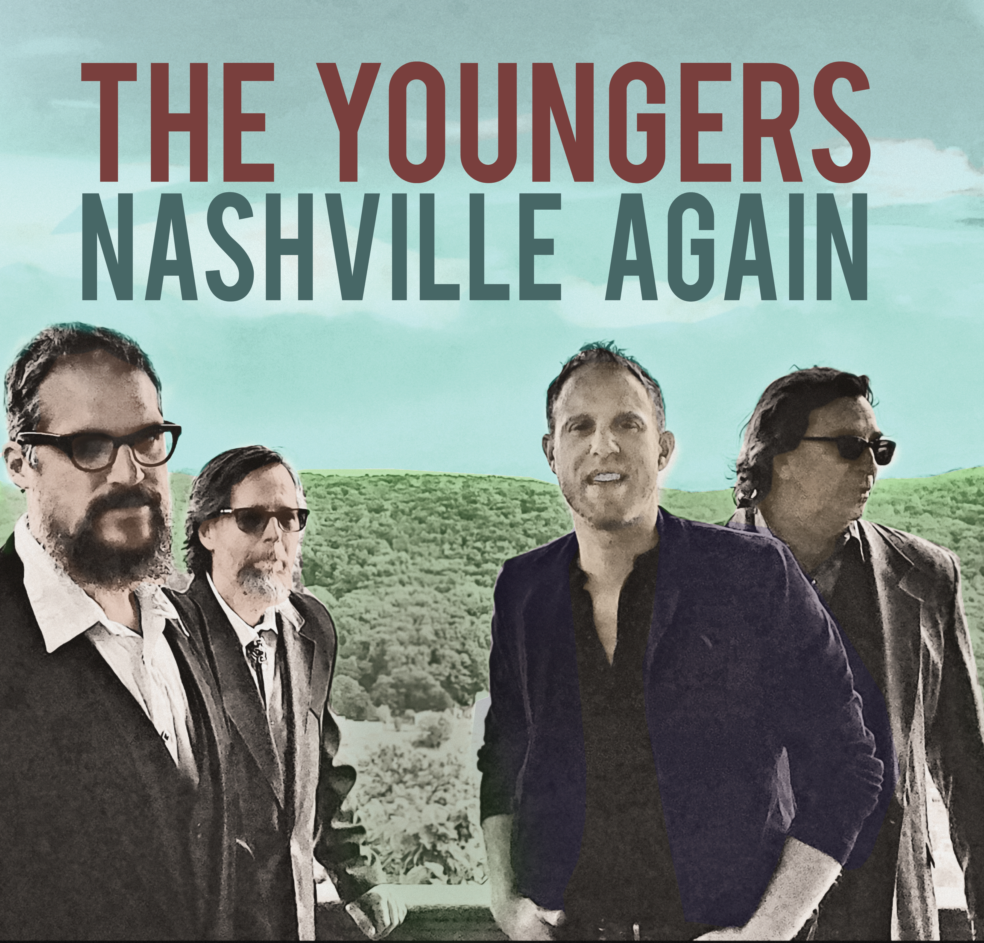
The Youngers
Nashville Again
(Let It Roll Records)

The Youngers are poised to release their fourth full-length album in early 2022 entitled Nashville Again, which follows Picture of You (2016), Heritage (2008) and Output (2005). A rollicking journey through the band’s stylistic influences, Nashville Again signals the band’s return to Music City.

Hailing from southeastern Pennsylvania, The Youngers were founded in 1999 by Todd Notobartolo (vocals, guitar, lap steel, and mandolin) and Randy Krater (vocals, electric and upright bass). Joining them are bandmates Matt Thren (guitar) and Bruce Kissinger (drums).

In 2016, The Youngers released Picture of You. The entirely fan-funded Picture of You project was recorded at the venerable Sound Emporium in Nashville, TN and engineered by Grammy®-award winner Chuck Turner.

Released in 2008, the critically-acclaimed Heritage album was recorded at the Cash Cabin in Tennessee and produced by John Carter Cash, son of country music legends Johnny Cash and June Carter. Heritage hit the top 30 on the AMA Americana Chart and featured an all-star lineup of guests including Laura Cash on fiddle, Ronnie McCoury (Del McCoury Band) on mandolin and the late pedal-steel legend Ralph Mooney.

The Youngers are no strangers to big festival stages, having performed at Delfest in Cumberland, MD and Musikfest in Bethlehem, PA, the nation’s largest non-gated free live music festival. They have also shared stages with legends like the late Levon Helm at his famed “Midnight Ramble” and opened for Marty Stuart, Lee Rocker, David Allen Coe, Wayne Hancock, and most recently, Billy Bob Thornton and the Boxmasters.

Their music has been featured on NPR, Sirius XM Radio, and Cowboy Jack Clement’s Radio Show and the band has garnered glowing reviews by Vintage Guitar Magazine and the Philadelphia Inquirer.
All Songs Are FCC Clean
Radio Single: Willie McCoy
Additional Recommended Radio Tracks:
“Memphis”, “Cat Eyes”, “Nashville Again” “Highway Blues”

